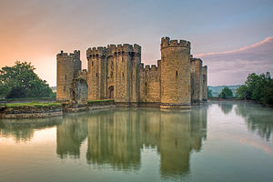

**Science:** Our topic is Seasonal changes. We will investigate shadows by using Jenga blocks to create a castle. We will then record the movement of the shadow over time.

We will also be learning more about seasons and will take a daily weather forecast. We will note the changes over time.

**Maths:** This term we will be focussing on Number and Place Value. Children will be consolidating their counting knowledge from reception to build on their number fluency. Within Maths, there will be an emphasis on reasoning problems as well as practical investigations.

**Music:** The children have weekly singing sessions with Mr Vinten as well as music lessons. In Music, the children will listen to music from medieval England as well as other countries.

**PE:** Children will take part in the weekly run to improve their fitness. They will also have weekly PE lessons to improve movement and coordination.

**History / Geography:**

We will be walking around the local area to compare different homes and shops. Year 1 will be discussing their hobbies and thinking about how these may have changed over time and in different communities across the world.

As our end of topic finale, we will be visiting a castle, there will be more information about this soon.

**Computing:** In our computing lessons, children will be introduced to basic computer skills on the Chrome Books. There will also be a focus on the importance of E-safety.

**English:** We will be writing postcards to another school from another country explaining about our home and local area. We will be focussing this term on our handwriting, finger spaces, capital letters and full stops. In Year 1, we go into the Digiverse to immerse the children in a castle.

**Art / DT:** In DT we will be planning, designing and building our own huts. In our Art lessons, we will be focussing on the artist Paul Klee to understand how he used shape and pattern.

**PSHE / Values:** We will be doing our weekly Votes for Schools sessions where children discuss and vote on global issues. Our PHSE topic for this term is ‘Being Me in my World.’

**RE:** Our topic for this term will be ‘Why are we thankful?’ We will consider different cultures and compare these to our own.

Castles, Huts and Homes

Year 1 Autumn Term 2019