Year 2 Learning - AutumnTerm 2019
English
During our English lessons, we will be covering a range of genres including: re-telling stories (looking at alternative endings), non-chronological reports, tongue twister poetry and diary writing.
Walking with Beasts
Geography
In Geography the children will study volcanoes. We will study the different parts to a volcano and its physical features.
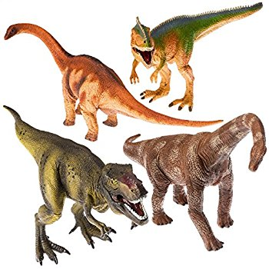

Maths
Our maths lessons will start with growth mindset this year. We will be thinking about what we love about maths and how to overcome what we think is tricky. We will be carrying out lots of fun, practical, open ended investigations. We will then move onto number patterns place value, addition, subtraction, muliplacation and division.
Science
In the first half of this term in Year 2 will be looking at habitats. The children will be taking part in an exciting science experiment involving mini beasts, this will kick start with a minibeast hunt around school.

We are really looking forward to our topic of ‘Walking with Beasts’ and all the discovery learning based around it. We will be bringing this learning to life by a visit to the Natural History Museum as well as a ‘Palaeontology day’. We will all become palaeontologist and we will dig for fossils and have a surprise visitor!
The Year 2 Team

Miss Meekings & Miss Spooner
History
History this term will be focusing on dinosaurs and famous archaeologists in history! We will start by learning about Mary Anning. Then, we will be looking at different types of dinosaurs, the periods in which they existed and what the earth was like during this time. We will also learn about how the dinosaurs became extinct as well as how the earth has changed.
Music
Exploring Rhythmic Patterns. To develop children’s ability to create simple rhythmic patterns and perform them using notation. Pitch – High and low

Computing
The children will create a talking book using powerpoint & voice notes with all they have found out about Mary Anning. They will then present it to the year group.

R.E
Our RE focus this half term will be on Islam, looking at places of worship and religious customs.
DT
The children will be making sandwiches this term! We will be considering healthy options, how to prepare food safely and discuss the choices we make with our food.

