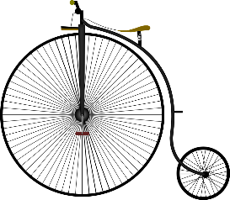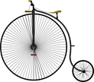

**English links:** Key texts include Street Child, Oliver Twist, Songs of Innocence and Experience

Children will write a range of texts including letters, diaries, reports, job applications/descriptions

**PHSE / Values:** Weekly votes for schools sessions.

Investigating child labour throughout the world.

**Additional:**

Digiverse – workhouse, Dr Barnado and Lord Shaftesbury

Educational visits

**Music**: Songs from Victorian era. History of orchestra and influence of Victorians on modern arrangement

**RE**:

Christianity – Bible

Islam: Worship, Festivals and Practices

**MFL / International:** Global Scholars program

French – food, animals, seasons

**Art/DT :** William Morris, mechanisms in wooden toys

**History**: Children will learn about who the Victorians were and what life was like for children living in this era. They will experience what a typical school day was like, discover the workhouse and what children did for fun. They will learn about jobs poor Victorian children undertook and influential people who helped improve the lives of children.

**Geography**: Children will look at maps from the Victorian age and compare the locality to now. In Global Scholars sessions, we will use geographical terminology when describing our area.

**Science**: Our science topics this term are forces - friction, steam power, air resistance. We will also learn about mechanisms - pulleys, gears, levers. We will also learn about the expansion of the railways during the Victorian age.

**Math links:** During our Victorian school days, children will have maths lessons in the style of rote learning (chanting times tables etc.). Children will also follow our mastery curriculum, which focuses on place value, addition, subtraction, multiplication, division and measures.

***Year 5***

***Topic:* We are not amused! (Victorians)**

***Entry Point: Role play a Victorian school day and Queen Victoria visits (plant a tree)***

***Mid Point: Workhouse Day***

***Exit Point: Educational Visit***

**Computing**: Children will be working on Chromebooks throughout our Global Scholars program (e-classroom, making video, digital literacy)