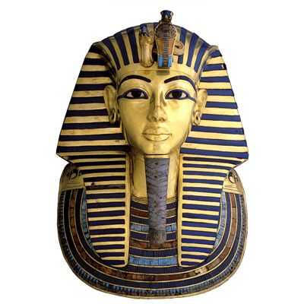

English links: Newspaper reports- The Egyptian Cinderella

Poetry- The Scarab’s Journey, Narrative Writing- The Prince of Egypt, The Mummy’s Finger- Fiction

Maths Links: place value up to 1000, addition and subtraction to 1000, rounding to the nearest ten, hundreds and thousands, all times tables facts up to 12x12. Use of hundred square on the playground for timetables games.

Additional: The trip will take place on Thursday 21st November 2019.

DT:

The children will be mummifying a sardine and will be designing a group Sarcophagus.

History / Geography: The children will be using atlases to locate Egypt and will be learning about the physical features of the landscape.

In History, we will be exploring how the Ancient Egyptians lived.

Art:

We will be looking at the artist Picasso and creating our own portraits. The focus will be on use of colour, composition and perspective. We will also be creating some large collaborative work for the gallery!

RE:

This term, the children will be exploring Christianity including the early life of Jesus and his teachings.

MFL / global links: In French, the children will be learning to talk about different animals and members of the family.

PE: Coaches will be teaching a range of skills and techniques within a variety of disciplines.

Computing: In our computing lessons, the children will be learning the importance of staying safe online and using Scratch software. We will also make use of the new immersion suite!

Music:

Mr Vinten will be teaching the children to read, write and perform their own musical compositions using keyboards.

PHSE / Values:

The children will be exploring how to be a good citizen, working as a team, their rights and responsibilities and democracy within our school. They will also be taking part in numeracy debates linking to our ‘Votes for Schools assemblies.’

Science

The children will be investigating different aspects of sound including how sounds are made, how they travel, change and can be recorded.

We will also be looking at different states of matter and classifying materials into solids, liquids or gasses.

Walk Like an Egyptian

Entry Point: A scavenger hunt to find exciting facts about our new topic.

Exit Point: A trip to the New Victoria Theatre, to watch a performance of ‘The Awful Egyptians’ by Horrible Histories.