Trips: The children will visit Fishbourne Roman Palace in Chichester.

Computing:

We are presenters!

The children will be looking at using iMovie or WeVideo to video performances and edit.

DT/Art : Trip to Pizza Express to make pizza and learn about its origins.

Focus on the artist Andy Goldsworthy.

Roman Mosaics

Music: Recorders and music based on Discovery topic, Harvest and then Christmas songs!

PHSE / Values:

Based on the Excellent 8 values.

Weekly Votes for Schools assemblies.

RE:

Symbols in religion

The Christian Bible:

Contents and structure

MFL / global links:

E-twinning links with Italian Primary School.

French to be taught.

Class emails:

3B – 3b@chipstead.croydon.sch.uk

3J – 3j@chipstead.croydon.sch.uk

3G – 3g@chipstead.croydon.sch.uk

PE:

Year 3 have PE taught by their class teachers on Tuesdays focusing on: Invasion games and Dance.

Year 3 will also have fitness sessions on Mondays and a coach lead session on Wednesdays.

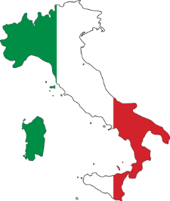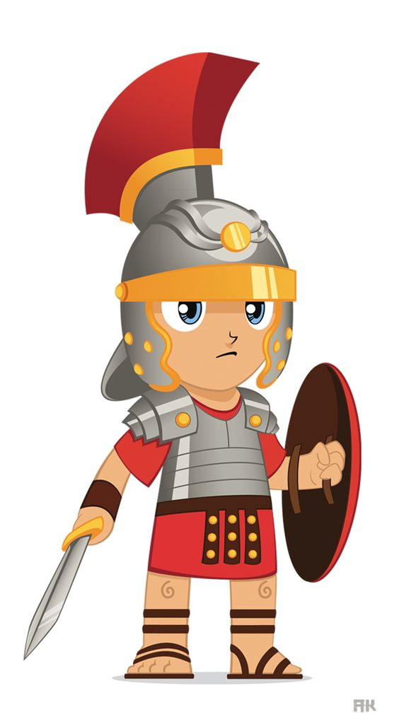

***Roaming Romans!***

Entry point: Children travelled to Italy within our Digiverse.

English links:

Traditional tales/ fables, play-scripts, newspapers/ recounts, instructions and poetry (vocabulary building and limericks).

History / Geography:

* Why do people move away from where they were born?
* Who were the Celts and who were the Romans?
* Who was Boudicca? What were the short-term and long-term results of Boudicca's revolt?
* How did the Romans change Britain when they settled here?
* How does Britain compare to Italy?
* Children will learn to examine different sources of evidence and why they may contradict each other.

Science: Our new science topic is ‘Forces, friction, magnets and springs’. Key questions will include:

* What makes things move?
* How can we stop objects from moving?
* What are magnets? How do they work?
* What materials are magnetic?
* How can we measure force?
* What is friction?
* What is water and air resistance?

Math links:

Reasoning within 1000 (counting and comparing), Number and place value, geometry, addition and subtraction, statistics.