Day | Theme and Activity | Additional Resources
Day One | Theme- Same But Different  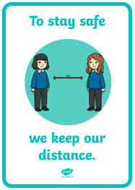  Watch the video: https://www.youtube.com/watch?v=J82L14IMU2k  Think about how things are the same but different at the moment. You could write these down or have a conversation with someone you live with.  Make posters about social distancing to display around the house, ‘catch it, bin it, kill it’, hand hygiene. | Coronavirus E-book:  https://nosycrow.com/blog/released-today-free-information-book-explaining-coronavirus-children-illustrated-gruffalo-illustrator-axel-scheffler/
Day Two | Theme- How do we feel?  Talk about how it is okay not to feel okay but it is important to talk to someone if you are feeling unhappy or unsafe.  Play a game of charades emotions with someone you live with at home or virtually through Zoom, FaceTime etc- can the other person guess the facial expression and name the feelings?  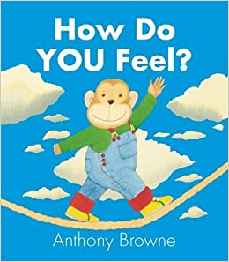  Watch the video: https://www.youtube.com/watch?v=kILR7wfi-X4  Create your own version or page from the book “How do you feel?” | Story: In my heart: The book of feelings  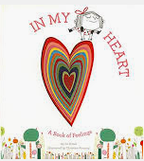  https://www.youtube.com/watch?v=xIfLgHBwYx4
Day Three | Theme- Gratitude  What is gratitude? Discuss and share definitions of gratitude. Think about how we show our thanks. How do we feel when we give thanks? How does it feel to be someone who receives thanks?  Think about the material and non-material things we might be grateful for and not always notice. Were you involved in the Thursday evening clapping for key workers? This was a good example of how giving thanks brought people together.  Watch the video: https://www.youtube.com/watch?v=XFQZfeHq9wo  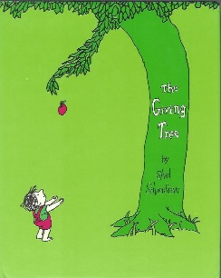  Talk about things we are grateful for. Write down things you are grateful for on pieces of paper and tie onto a branch to create a gratitude tree. You could also draw your own tree and write your ideas onto this.  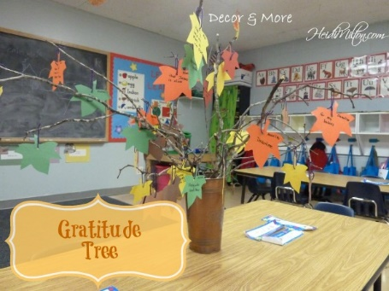
Day Four | Theme- Hope  Think about how rainbows have been a symbol of the pandemic- remember that there are no rainbows without rain and that lots of people have been displaying them in the windows of their homes.  Watch the video: https://www.youtube.com/watch?v=ccbPygaBeeE  Think about the meaning of the rainbow at the end of the story.  Discuss or write down answers to the following questions:  • How do you think Noah, his wife and family felt feeling trapped inside the Ark for over 40 days?  • How do you think they kept busy?  • How do you think they stayed hopeful?  • Have you got any advice for if they couldn’t go out for another 40 days?  • Can you think of a time when you faced something tricky and  weren’t sure how it would turn out, but you managed to stay hopeful?  Activity examples: Make a dream catcher, create an image of hope e.g. rainbow themed artwork  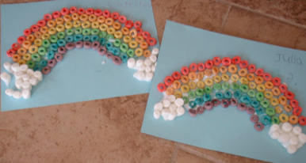  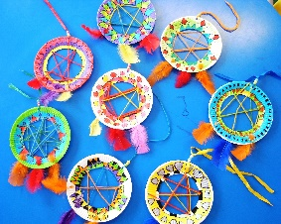  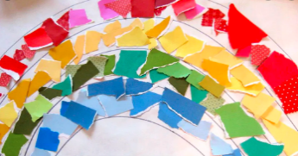
Day Five | Theme- Worries  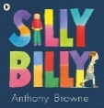  Watch the video: https://www.youtube.com/watch?v=vDE5pqAFPwU  We all have worries and adults can have worries as well as children. Worries are very normal and sometimes talking about them can help.  In school we have a worry box or jar, do you want to create something at home to put your worries into?  Activity: Research and understand more about worry dolls. Create a poster displaying your findings about worry dolls. If you are feeling creative, you could even have a go at creating your own!  