**Key Dates:**

Chinese New Year (22 Jan)

St Valentine’s Day (14 Feb)

Shrove Tuesday - Pancake Day (21 Feb)

St David’s Day (1 Mar)

‘**Topic at a Glance’**

**Medium Term Planning Spring 1: 4.01.23 – 10.02.23**

**Space and the Planets**

*Encompassing Personal Social Emotional Development, Communication and Language, Physical Development, Literacy, Numeracy, Understanding of the World, Expressive Art and Design*

Aliens, Spaceships, planets, sun/moon, stars, rockets, countdown, light table, ‘5 little men’, aliens, paper pate spaceships, galaxy messy play, experiment with weight, space explorer with photo, shiny/silver materials.

Focus activities: Baking Moon Rocks & Digi Verse visit to explore Mars

**Birds and Winter Animals**

*Encompassing Personal Social Emotional Development, Communication and Language, Physical Development, Literacy, Numeracy, Understanding of the World, Expressive Art and Design*

Bird migration to warmer climate. Animals that hibernate. Habitats, Arctic and Antarctic animals. Igloos. Nocturnal animals, habitats, den/cave building.

Focus activities: making igloos and dens for winter animals.

**Up, Up And Away!**

**Pirates**

*Encompassing Personal Social Emotional Development, Communication and Language, Physical Development, Literacy, Numeracy, Understanding of the World, Expressive Art and Design*

Whole school art project based on painting ‘A shipwreck in Stormy Seas’. Making sea themed art, junk modelling boats, treasure maps, treasure hunt, message in a bottle, flags, skull & cross bones. Pirate ship role play.

**Artist of the Month: Art Input: contemporary Yayoi Kasuama Polka dot art**

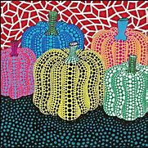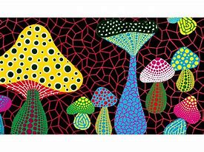

**Phonics:**

Using our name cards, start to identify initial sound in our name and learning to write our names.

Read Write Inc. ‘Sound of the week’ each week as follow:

9/1 - m 16/1 - a 23/1 - s 30/1 - d 6/2 – t

*Please see ‘Tapestry Memos’ for Mrs Standish’s video clips each week*

**Key Texts:**

