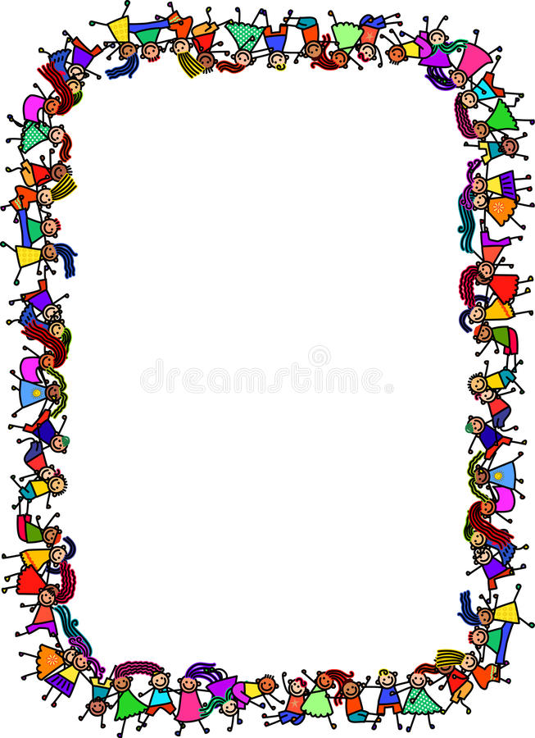

**Personal Social Emotional Development**

The children continue to have well-being lessons and we have encouraged the use of self-regulation charts so they can begin to understand their emotions as well as being able to discuss them with others.

The children continue to work on conflict resolution and managing friendship.

We have a well being journal where pages are updated based on questions from the curriculum.

## Expressive Arts & Design

We will be experimenting different materials and developing confidence in using these resources independently. The children are given free rein to use equipment and resources to create art relating to their topics and these are displayed within our classroom. The children have enjoyed expressing themselves through dance and role play.

## Mathematics

We are looking at 2D shapes using their names and recognises shapes within the everyday world.

For capacity we will be using language such as full, half full and empty.

We will continue counting up to 20 and singing number songs and playing number games.

Reception 2022-2023

Towers and Tiaras

## Literacy

We are giving children daily exposure to writing opportunities inside and outside of the classroom.

During phonics sessions, some children are now receiving reading books linked to the sounds they are learning and some children are continuing with their practise sheet to reinforce their learning.

We start each topic with a new book.

## Understanding the World

We have learnt about Diwali and The Christmas story. This term we are going to learn about Chinese New Year and identify the ways in which they are celebrated and comparing similarities and differences.

We will also learning about the people who help us and the importance of their job.

## Physical Development

We continue to explore the various funky fingers activities to strengthen our fine motor skills as well as daily name writing opportunities. Each day we will be given the opportunity to explore our outside area using the bikes, scooters and climbing frame. We have been developing our gross motor skills by exploring the woods each week and running up and down the bank carefully.

## Communication and Language

We are currently using the NELI screening to assess the children’s language and early literacy skills. The results from these will be used to inform intervention groups to support children where appropriate. The children are encouraged to use full sentences when asking/answering questions with adults and their peers.