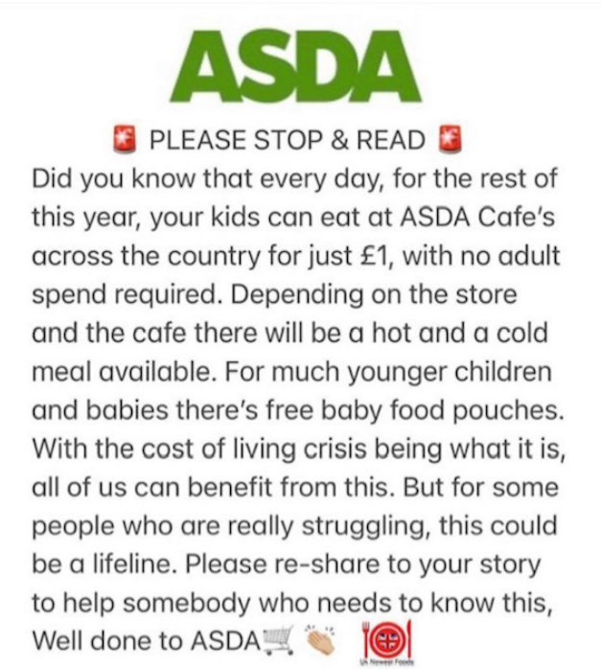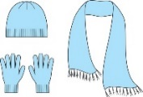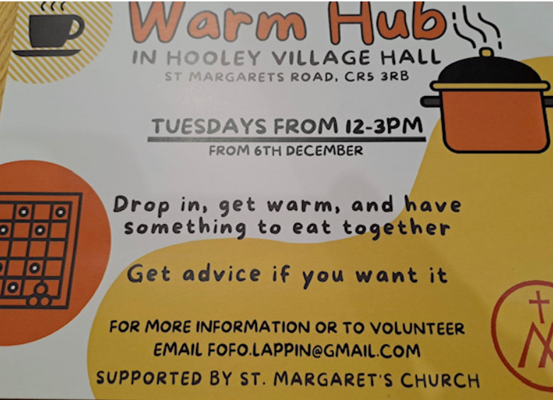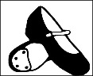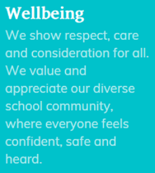**Chipstead Valley Primary School  
Wellbeing support through the financial crisis**

Winterwear Exchange  
Our winterwear exchange was very successful and we are incredibly grateful for all of your generous donations. We are looking to keep a stock of leftover donations in school to provide for any children in need throughout the winter months. In the coming months, we will also be thinking about further exchanges that we can host.

Asda Elderly Winter Warmer  
As well as initiative above, Asda is also offering those aged 60 and over the chance to enjoy soup, a roll and unlimited tea and coffees for just £1 in any of its 205 cafes all day and every day throughout November and December. Please share this with any elderly members of your family or our community.

We understand that the current financial situation is impacting so many families across our school community. Having listened to your comments and ideas from our recent parent survey, below are a few more initiatives both in and outside of school.

Purley Food Hub  
Purley Food Hub have continued to go above and beyond and support families in our school and local community. A time of crisis can happen to anyone, and Purley Food Hub are there to help.

In order to receive a food parcel, you need to be referred to them by one of their approved ticket partners, such as CVPS. We will let the food hub know how many adults and children there are in your family or household, the children’s ages, and if there are any young children needing nappies, wipes or baby/toddler food. We will also let them know if anyone has any special dietary needs, or requires female sanitary products.

Fruit  
All children in EYFS/KS1 are entitled to free fruit for their break time snack. We are distributing any spare fruit to children in KS2, who otherwise would not have a snack.

Shoes  
We are requesting **any** old school shoes of **any condition** to provide a free shoe exchange, for those that may need it. Through an incredibly kind shoe cobbling business within our school community, we will be able to make any old shoes wearable again to benefit another family. If you have any shoes at home to donate, please send these in with your child or to the school office.