****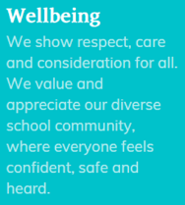******Chipstead Valley Primary School  
Wellbeing support through the financial crisis**

As a school, we understand that the current financial crisis is impacting so many families across our school community. As a result, we recently sent out a survey to gain a deeper insight into how it is impacting our children and parents, as well as gaining some valuable suggestions to help.  
  
We really appreciate the time taken to complete the survey and were overwhelmed by the response. It is clear that many families across our school community have been and continue to be impacted by the crisis in a variety of different ways. As a school, we aim to always go above and beyond to support those that need it in any way that we can. With your survey suggestions, below are some of our initiatives.

Fruit  
All children in EYFS/KS1 are entitled to free fruit for their break time snack. We are now distributing any spare fruit to children in KS2, who otherwise would not have a snack.

Winterwear Exchange  
With the cold weather approaching, we recognise that children grow out of items of clothing quickly and it can become expensive for families. With this in mind, we will be holding a winterwear free exchange at CVPS.  
  
If you have any winterwear of **good** quality at home, please send these to the KS2 hall on the 24th November before or after school to donate. Items we are specifically looking for are:

* Coats
* Hats/gloves/scarves
* Wellies

The winterwear exchange will enable families in need, to ensure their children are kept warm throughout the Winter months.   
  
We will hold the winterwear exchange on 25th November in the KS2 hall, before and straight after school. Please come along!

Purley Food Hub  
Purley Food Hub have continued to go above and beyond and support families in our school and local community. A time of crisis can happen to anyone, and Purley Food Hub are there to help.

In order to receive a food parcel, you need to be referred to them by one of their approved ticket partners, such as CVPS. We will let the food hub know how many adults and children there are in your family or household, the children’s ages, and if there are any young children needing nappies, wipes or baby/toddler food. We will also let them know if anyone has any special dietary needs, or requires female sanitary products.  
  
Purley Food Hub are also once again asking for families to be referred to receive an Aldi voucher to buy a Christmas meal, as well as a toy for Christmas.

Please let us know if you are in need of any of these services and we will happily refer you.  
  
To support this local hub, our recent harvest donations all went to support Purley Food Hub and any donations during our Christmas Carol Concert will also go to this amazing cause as well.

Shoes  
We are requesting **any** old school shoes or **any condition** to provide a free shoe exchange, for those that may need it. Through an incredibly kind shoe cobbling business within our school community, we will be able to make any old shoes wearable again to benefit another family. If you have any shoes at home to donate, please send these in with your child or to the school office.

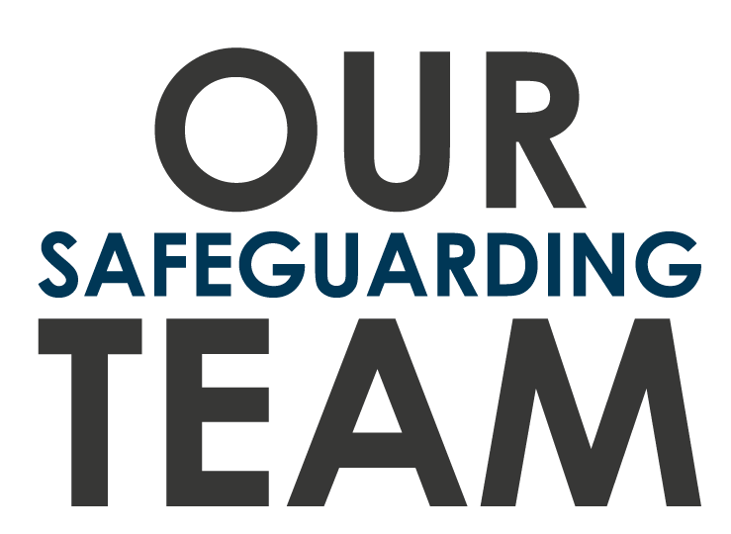

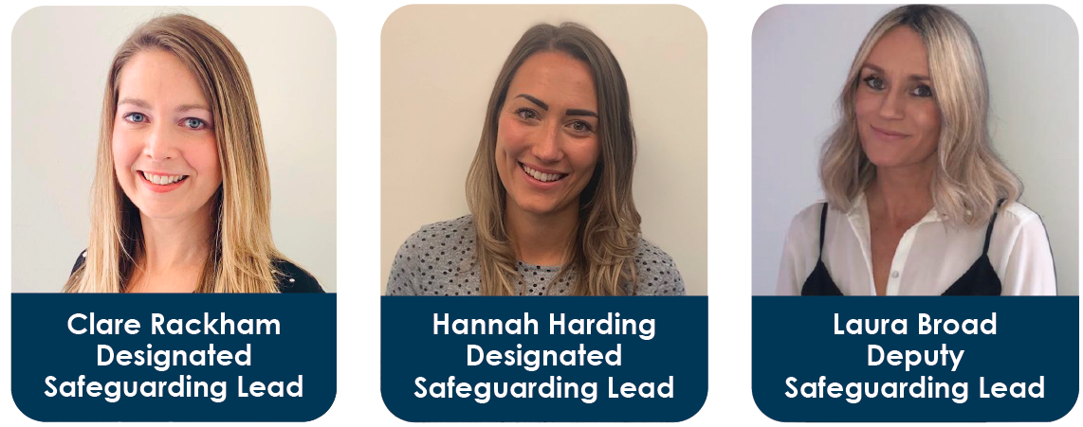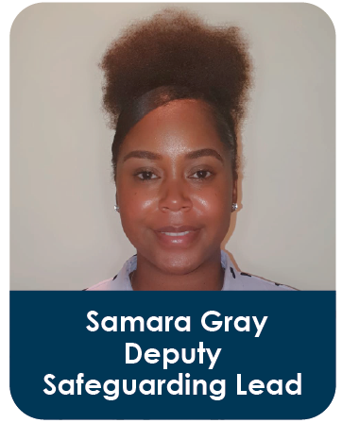  
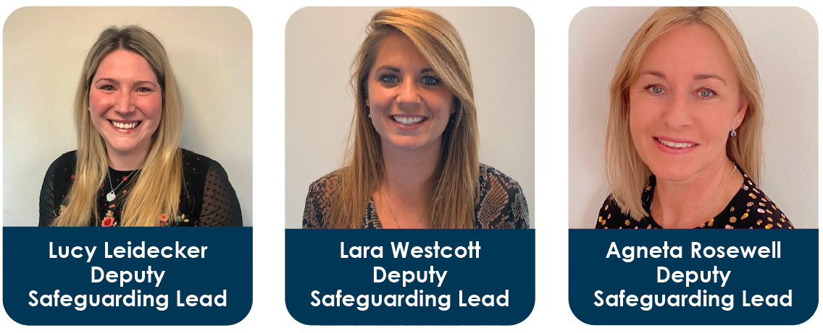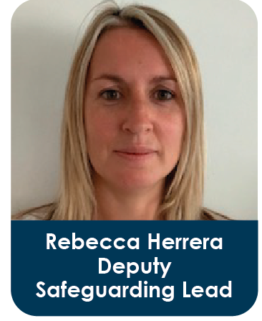

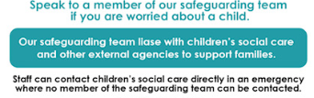  
Our safeguarding team are here to listen, help and support your family.

********

Financial Support Services  
Utility Warehouse (UW) is a website, which offers the cheapest variable energy tariff available today - even cheaper than the government's Energy Price Guarantee.  
Visit: https://uw.co.uk/

Costume Exchange  
Within the survey sent out, many parents suggested holding a costume/fancy dress exchange. We think this is a great idea and will plan for this to happen next term!

School Events  
As a result of the survey, we understand that many parents feel the financial pressure of multiple school events throughout the year. To aid some pressure, the PTFA will be limiting the amount of mufti days as well as fundraising events throughout the year.   
  
We will also be holding a Christmas craft day, instead of Christmas jumper day this year, as many parents felt that was buying a jumper was an added expense.

Warm Hubs  
'Warm hubs' are intended as a local as places within communities where people can find a safe, accessible and warm environment during the day to help reduce the cost of heating their own homes and to help those facing extreme fuel poverty this winter.

Here are some Surrey based warm hubs:   
<https://www.surreycc.gov.uk/health-and-welfare/support/welfare-support/everyday-living/warm-hubs>

Supermarket Vouchers  
If a family is entitled to pupil premium funding, their child will receive free school meals as well as supermarket vouchers within the school holidays (thanks to Marcus Rashford!)  
If you believe you could be eligible for this support, please put your details into checker:  
[Free School Meal Eligibility Checker (lgfl.org.uk)](https://pps.lgfl.org.uk/)

Essentials Box  
As a school, we are looking to go above and beyond to support our families in need. We will be creating ‘essentials boxes’ with items such as toothpaste, toilet roll and wipes.   
  
If you are in need of one of these boxes, please email [mwright@chipstead.croydon.sch.uk](mailto:mwright@chipstead.croydon.sch.uk), to arrange a discrete collection time, when available,

School Trips  
From the survey, some parents told us that school trips can be an added financial strain. With families having an increase in their own spending, we also know that this will impact extra opportunities outside of school, so school trips are also hugely important. We are aiming to keep costs down for school trips, and at times using public transport where possible. If you need any financial help with a school trip, please let us know as we support all families to ensure their children do not miss out.

Wellbeing Curriculum  
Our tailored Wellbeing curriculum offers children a safe place to learn and discuss their feelings, emotions and the wider world. With the financial crisis, children are very likely to pick up on news report, conversations and the emotions of adults around them. Our curriculum teaches children to tools to understand how they feel and how to communicate these with others. The world can be an amazing but tricky place and it is vital that our children learn how to be resilient.

Sanitary Products  
As a school, we have a large stock of sanitary products to end period poverty. All children in Year 5 and 6 have a stash of these in a cupboard and a variety are kept in the main school office as well.

Other Food Banks  
As well as Purley Food Hub, there are also three ‘Food Stops’ in the borough, which offer £15-£20 of fresh food and groceries for £3.50 a week:

[**Purley Food Stop**](https://www.facebook.com/purleyfoodstop/), Old Lodge Lane Baptist Church, Reedham Park Avenue, Purley CR8 4BQ ‐ Fri 10am ‐ 12noon.   
[Click to email](mailto:foodstop@ollbc.org.uk)

[**Monks Hill Food Stop**](https://www.stfrancismonkshill.org.uk/), St Francis Church, 146 Tedder Road, Monks Hill, CR2 8AH ‐ Fri 10am ‐ 12noon.  
[Click to email](mailto:stfrancisselsdon@gmail.com)

[**Fieldway Food Stop**](https://www.facebook.com/The-Family-Centre-341194682608636), Family Centre, Fieldway, New Addington CR0 9BS ‐ Tue & Wed 10am ‐ 12noon.  
[Click to email](mailto:familycentre.fieldway@virgin.net)

Croydon Music and Arts (CMA)  
Croydon Music and Arts (CMA) is a service within Croydon Council. They work to ensure children and young people in the borough have access to creative opportunities and many children currently have paid music lessons through this service at school. If your child is eligible for pupil premium and are wanting to learn a musical instrument, please let us know as this can be funded.  
  
As well as this, children at CVPS are incredibly lucky to have our specialist Music lead, Mr Vinten. All children learn the recorder in Year 3 and the keyboard in Year 4, as part of our music curriculum.