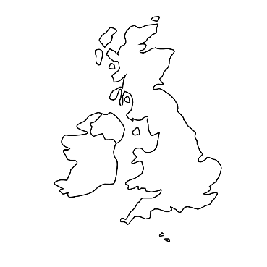

**Year 1**

**Brilliant Britain**

**Maths:**

In maths, we will begin to look at place value of numbers up to 20, introducing them to 2-digit numbers and what each number means. Using this information, we will add and subtract numbers up to 20.

**English:**

In English this term, the children will continue to look at different styles of writing. They will retell a familiar story using actions to help us. Finally, we will look at letter writing.

**Science:** In science the children will begin thinking about the seasons and weather changes throughout the year and being able to recognise how and why the weather changes with the seasons.

**Wellbeing Curriculum:** In our wellbeing lessons we will be looking at who keeps us safe? Who keeps us safe at school, at home and in public?

**MFL:** The children will continue to learn Spanish this term and will move on to colours, animals and days of the week.

**PE:** During PE, Year 1 will continue to work on their ball skills and their hand-eye coordination and applying that to a range of games.

**Art/DT:** In art, the children will be exploring primary and secondary colours as well as cold and warm colours.

**Computing**: In computing this term, the children will be learning about online safety and learning how to log in and out of a device.

**Music**: The children will continue to work with Mr Vinten in their music lessons this year. The children will continue to focus on rhythm and body percussion to create a beat.

**RE:** In RE this term, our foundation is ‘Growing Together’, focussing on Judaism.

**History:**In history, we will be comparing things from the past to things today with reference to London. What did London look like? What did people do? Why has it changed?

**Geography:** In Geography we will focus on the UK. We will find out where the UK is on a map and the four countries that make up the UK. We will also identify capital cities and other large cities in each of the four countries as well as the seas that surround it. We will also begin to accurately read maps to identify where we are. We will then focus on London and the characteristics of that location.

What does the UK look like? We will look at contrasting areas including towns and villages. Different areas that have hills, mountains, oceans, farms, churches and different kinds of houses.