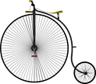

**English:**

During our English lessons, the children will learn to write a diary, a recount about the trip, and instructions linked to ‘George’s Marvelous Medicine.’ In addition to this there will be a focus on grammar. The children will learn about prefixes and suffixes, adverbs, sentence types and present tense.

**Science**:

In their science lessons, they will observe and describe how seeds and bulbs grow into mature plants and find out and describe how plants need water, light and a suitable temperature to grow and stay healthy. This will link to our science week.

**Maths:**

The children will be developing their understanding of addition and beginning to understand and consolidate their learning of a variety of different subtraction methods. They will be using dienes and number lines to support their learning.

In addition to this, the children will begin to learn about multiplication by using practical and written methods.

**Wellbeing Curriculum:**

As part of our well-being curriculum, the children will be looking into where do we belong? What/who keeps me safe? How can we look after other living things? What effects do we have on our environment?

***Year 2 – Spring 1***

***Location, Location, Location***

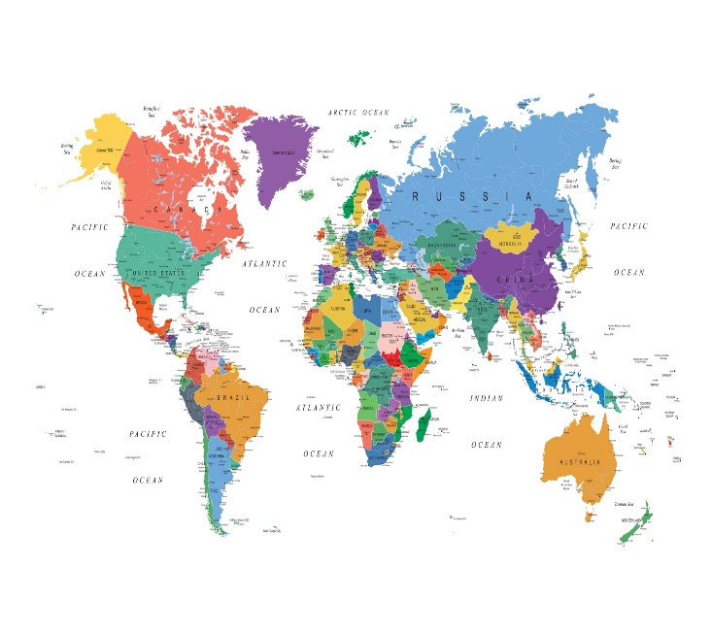

**Computing**:

The children will be introduced to the programme, ‘Scratch.’ They will learn and use positional language to move their character, ‘Sprite.’

**MFL:**

During this term, the children will continue to develop their Spanish vocabulary. The topic will be called, Language Learning Powers.

**Art:**

During art lessons,

**RE:**

The children will be learning all about Islam. During this unit, they will be learning all about the places of worship and the different lifestyles and celebrations.

**Music**:

The children will be focussing on performing, composing and appraising their music linking to

**Geography:**

In the children’s geography lessons, they will learn to describe a place outside Europe using geographical words, explain what facilities a town or village might need and explain how the weather affects different people and climates.

Describe some of the features associated with an island

**PE**:

Throughout this term, the children will be introduced and taught basic netball skills. They will learn to pass, catch, pivot and some of the rules.

**Reminders:**

Please note