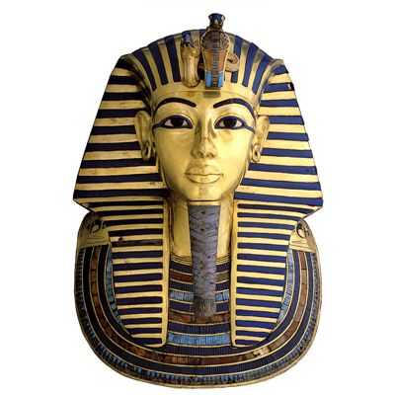

Discovery homework grids have gone out to complete over the course of this term- we look forward to seeing your work!

Maths: The children will be continuing to work on their fluency skills. In addition to this, they will be learning about multiplication, division and area. We will be continuing with our investigative skills alongside this as well as our times tables practice.

Science: We will be learning about the functions of the digestive system in humans and understanding about teeth. We will also learn about food chains, identifying producers, predators and prey.

Reminders:

* Swimming on Mondays
* PE on Tuesdays and Thursdays (please keep trainers in school every day)
* Homework / spellings are handed out on a Thursday
* Homework is due in on Tuesday; spelling test is completed on Thursday
* Times tables quiz is each Tuesday

MFL / global links: In Spanish, the children will be learning the months, facial features and family members.

English: This term we will be writing our autobiographies based on Cleopatra. We will also be creating our own playscripts and continuing to embed our grammar learning of prepositions, conjunctions and fronted adverbials. The children will be writing their own stories based on ‘The Egyptian Cinderella’.

Wellbeing: This half term, we will be thinking about what keeps us safe and how to respond in emergencies.   
  
The children will also be taking part in “Children’s Mental Health Week”, where the theme for this year is “Let’s Connect”. We will be having lots of discussions around this theme!

Walk Like an Egyptian

Geography: The children will be using atlases to locate Egypt and will be learning about the physical features of the landscape. They will also locate and label different countries in the Northern and Southern hemisphere as well as naming the different climate zones.

Music: Year 4 will be working on keyboards and developing the skill to read and play from the treble and bass clef.

PE: The children will be focusing on Egyptian dance this term.

RE: This term we will be thinking about the question, “Why do you judge me?” We will be discussing stereotyping and labelling.

Art: We will be continuing to develop our understanding of colour, matching colour to colour charts and experimenting with creating mood in an Egyptian scene. We will also be developing our awareness of composition, background and foreground as well as the effects of light and dark.