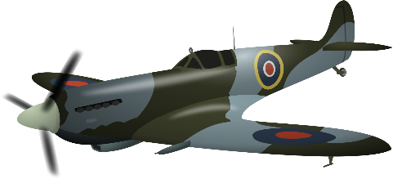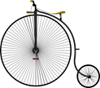

# English links: We will be using range of stimuli for creative writing: The Emergency Zoo for persuasive speeches and narratives; Cannes Lion Award-Winning advert of "Three Little Pigs" for newspaper with bias.

We will also cover diary writing; emotive letters and we will write a school policy. The children will continue to build on their knowledge of grammar and punctuation through a range of writing opportunities.

* Equality and diversity
* International/global
* Community
* Outdoor learning
* Immersive technology

***Year 6***

***Topic: Bombs Away!***

**Geography:** We will study the countries involved in WW2 and look at some of the major events that occurred in various places across the world during this time. Where possible, we will be using the Digiverse to place us in some of these locations.

**Art:**

We will be studying the wartime artist Henry Moore and creating our own London Underground evacuation artworks with a focus on perspective and tonal shading.

**MFL:**

This term we will be learning about healthy eating, going to the market and healthy recipes.

**PHSE / Values:**

Wellbeing curriculum:

What/who helps me to keep safe?

How do I keep myself safe?

Children’s Mental Health Week

**Music**: We will be focusing on music related to World War II. The children will experiment with recording their compositions in different ways.

**RE**: We will be looking at the belief system of Judaism and how they express their faith. In addition to this, we will be touching upon the experiences of Jewish people during wartime.

**History**: Our theme this term is based around World War II. We will be learning about The Blitz, propaganda, the countries involved, evacuation, shelters and much more! We will also be looking at the experiences of GIs from black ethnicities while stationed in the UK

# Maths: This term we will be focusing on fractions, decimals and percentages.

**Science**: Living things and their habitats

We will describe how living things are classified into broad groups according to common observable characteristics and based on similarities and differences, including micro-organisms, plants and animals. We will also give reasons for classifying plants and animals based on specific characteristics​.

**Reading Vipers:**

We will be focusing on answer techniques and how best to answer different types of questions related to the class texts with specific focus on three-mark questions.