Behaviour Policy

Agreed by Governors: February 2024

Review Date: September 2025
Aims

The PACE Academy Trust promotes high standards of children’s behaviour, based on certain expectations. Promoting good behaviour is the responsibility of every member of the school community.

Chipstead Valley Values
At Chipstead, we promote the following 8 values:

Co-operation
Respect
Resilience
Thoughtfulness
Communication
Enquiry
Morality
Adaptability

The Valley Values are introduced and revisited in our B Badge celebration assemblies each week. Each term, children in Years 3, 4, and 5 receive special Valley Values awards, linked to a sustained demonstration of these qualities. They are explored regularly by the children in dedicated learning time to promote ownership and understanding behind each of the Valley Values. These values are displayed around the school and on the wall of each classroom. They are referred to continuously by all members of staff and are embedded in all that we do. Through consistency of approach by all, the boundaries of acceptable behaviour and attitudes to learning are clear. Children consistently receive positive feedback for what they do well.
We always aim to ‘Be the Best We Can Be’.

Rewards
- Positive feedback (members of staff to always congratulate children);
- Children present their work to the class or share it with members of Senior Leadership or Headship Team;
- ‘B’ Badge certificates are awarded in a dedicated assembly each week. Children in Reception/KS1 receive a bee sticker and KS2 a ‘bee’ badge for the week. Certificates are displayed outside classrooms to celebrate achievements.
- Thoughtfulness certificates will be given to children within the school who have demonstrated exceptional kindness to another person;
- Houses: team points are awarded for children who demonstrate the the Valley Values and Golden Expectations;
- Sharing of positive achievements with parents. Staff will write positive comments in contact books;
- Trophies and certificates are awarded for supreme effort within different subjects;
- Within class, teachers will promote positive behaviour through class reward strategies (which may include stickers, Dojos, behaviour charts, marbles, table points etc) at the teacher’s discretion;

Sanctions
The school employs sanctions to enforce the Valley Values and Golden Expectations, and to ensure a safe and positive learning environment. These can be found in the Hierarchy of Sanctions, which includes the use of yellow and red cards for inappropriate behaviour during the school day, including breakfast and after school clubs. Responses are appropriate to the level of seriousness of the misconduct. Children have a clear picture of the progression through the hierarchy.
The use of ‘blanket’ punishments is actively discouraged as we prefer to identify and sanction individual pupil(s), with reasonable adjustments being made for children with additional needs.
If there are incidents of anti-social behaviour, the class teacher may choose to discuss these with the whole class during Wellbeing lessons.
Resolving Conflicts
Children are encouraged to take responsibility for sorting out their own conflicts. Members of staff model resolution strategies and support the children in reaching successful conclusions. Resolving conflict is also taught explicitly within our Wellbeing curriculum.

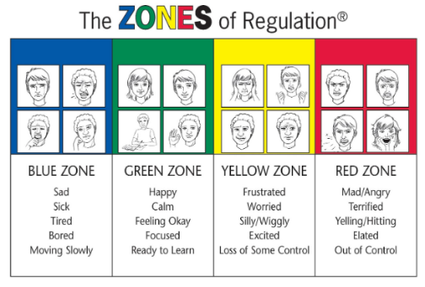
Zones of Regulation
At CVPS, we use the Zones of Regulation to teach children how to regulate their emotions by categorising feelings into four coloured zones. The Zones of Regulation framework provides strategies to teach children to become aware of and independent in recognising, naming and choosing a ‘tool’ to manage their emotions and impulses. This approach aims to improve their ability to solve potential conflicts and help to manage behaviour. There is a consistent approach to the use of the Zones of Regulation throughout CVPS, from EYFS to Year 6, with displays in each classroom.

Responding to Sexual Violence and Child-on-Child Abuse
Child on child abuse includes, but is not limited to:
• physical and sexual abuse;
• sexual harassment and violence;
• emotional harm;
• on and offline bullying;

It can take place between any pupils within or beyond the school.

At Chipstead Valley, we work hard to create an environment in which, children and staff show respect for one another and know what language and behaviours are acceptable. This includes a zero tolerance of violence or harassment of any kind; inuendo, banter or otherwise personally derogative comments. We support children to have a good understanding of consent and healthy relationships and to know what to do and who to speak to if they are worried or feel unsafe. Instances of child-on-child abuse should be dealt with according to the appropriate school behaviour or antibullying policies, including full investigation and appropriate separation of those involved to protect and support both parties. All behaviours falling within the remit of child-on-child abuse should be referred to the DSL.

Searching and Confiscation of Inappropriate Items
Our Headteacher, DSL and SLT have a statutory power to search a child or their possessions, where we have reasonable grounds to suspect that the child may have a prohibited item (knives, weapons, alcohol, illegal drugs, stolen items, fireworks, pornographic images, tobacco, cigarette papers and anything that could cause offence or cause personal injury to, or damage to property of; any person, including the child.)
Before conducting a search, school staff will always consider the age and needs of pupils being searched. This includes the individual needs or learning difficulties of pupils with Special Educational Needs (SEN) and making reasonable adjustments that may be required where a pupil has a disability. (For further guidance: Searching, Screening and Confiscation Advice for schools)

Different Approaches for Particular Children
Sometimes, a pupil will have a particular need or lived experience, which requires a different approach. For example, sometimes and for some pupils, it is necessary or beneficial to deliberately ignore inappropriate behaviour. These children, identified through discussion between class teacher, SLT, DSL and SENDCo team, will have a behaviour plan (and/or risk assessment) to outline how their behaviour will be managed. Some children may also have a personalised emotional support plan (see appendix 1).
Due to the SEND needs of our Treehouse class and ELP children, an adapted approach to behaviour may be necessary to suit the needs of these individual children.

Different Approach for EYFS Children
As a school, we believe that EYFS is a time for children to learn appropriate behaviour and strategies for managing this. It is our job to support them in this area of development and the sanctions for behaviour would be personalised to suit our EYFS children.
Other linked policies
The school does not tolerate bullying of any kind. When we discover that an act of bullying or intimidation has taken place, we act immmediately to stop any further occurances of such behaviour. All incidences of bullying are referred to the Head Teacher using the bullying incident report form. (See Anti-Bullying Policy).

Behaviour, which shows prejudice, whether racial, religious or cultural, is not accepted and will be dealt with immediately in line with our Anti-Bullying and Anti-Racism policy (See anti-bullying, anti-racism policies and Celebrating Diversity, Promoting
Equality: Our Policy and Commitments)

The Role of Staff
Staff must be consistent and treat children fairly. All members of staff deal with incidents of misbehaviour and apply appropriate sanctions. Consistency across the whole school is key. More serious incidents are reported to the class teacher for recording. Red card incidents must be reported to the Headship Team, who will make the decision on whether a card is to be administered. The Head Teacher will then issue parents with a Red Card letter, which will be attached to My Concern.

The Role of the Class Teacher
It is the responsibility of every class teacher to ensure that the Golden Expectations are followed. Each class teacher must ensure that their class behaves in a responsible manner during lesson time and around the school.

If a child misbehaves in class, the class teacher takes appropriate action (in accordance to hierarchy of sanctions). If a child continues to misbehave, the teacher involves the child’s parent; seeks help and advice from the Leadership Team (phase leaders, Senior Leadership Team and Headship Team).

The Role of the Head Teacher
The Head Teacher supports the staff by setting the standards of behaviour, implementing the policy and recording serious or repeated incidents on My Concern. The Head Teacher has the responsibility for giving fixed-term exclusions to individual children for serious acts of misbehaviour. For repeated or very serious anti-social behaviour, the Head Teacher may permanently exclude a child (PACE Suspensions and Exclusions Policy). These actions are taken in conjunction with the school governors.

The Role of Parents
The school works collaboratively with parents, so children receive consistent messages about behaviour. Parents receive messages home via contact books regarding their children’s positive contributions to school life. If parents have any concerns, they initially contact the class teacher. If the concern remains, a member of the Senior Leadership Team is involved. Parents may follow the formal complaints procedure, if they consider the matter has not been resolved.

The Role of children
The school expects children to take responsibility for their own behaviour and aims to give children responsibilities in which they can demonstrate and model good behaviour, for example:
- School Council – 2 per year group from Yr 1-6
- Eco Committee
- Librarians

The Role of Midday Supervisors (MDS), Breakfast and After-School clubs
Adults within these job roles should use the same system with the following adaptations:

- White forms should be passed by the lead worker to relevant class teacher, as soon as possible. Accountability Area time should be on the same day for breakfast club and the next day for after-school club. The class teacher must ensure attendance.
- MDS should consider all strategies to descalate behaviour before escalating to SLT.
- For any potential red card incidents, a member of the SLT should be contacted immediately.
- MyConcern must be used to log any behaviour incidents

The Role of the Local Governing Body (LGB)
The governing body are responsible for implementing and reviewing the effectiveness of the Behaviour policy and supporting the Head Teacher in carrying it out. Further guidance can be found within the PACE Suspensions and Exclusions Policy.

Managing Behaviour- including Child on Child abuse (to be displayed in classrooms for staff)
Minor Low Level Disruption
Examples:
- Refusal to follow instructions in the first instance
- Answering back to others
- Innapropriate use of equipment
- Running inside the school building
- Chatting or unfocused behaviour
- Distracting others
- Not following our “Golden Expectations”
Consequence: Immediate verbal warning/child discussion with adult concerned (all members of school staff)
Persistent Low Level Disruption
Examples:
- Repetition of the above low level disruption
- Using unkind words on the playground
- Not following instructions from an adult
- Misuse of school equipment
Consequence: 5-10 minute ‘time out’ with adult on duty, missed break/lunchtime or child sent to alternative class in year group agreed by adult concerned and class teacher. Member of staff to choose the appropriate sanction based on the individual’s specific needs. Log on MyConcern.
Yellow Card: Continued Poor Behaviour/More serious individual incidents
- Repeated persistent low level disruption or prolonged minor low level disruption
- Disrespecting a member of staff (including lying)
- Swearing or inappropriate language
- Refusing to complete classroom activities
- Aggressive pushing in the context of a ball game
- Provoking/goading other children
- Breaking or using equipment dangerously (including inappropriate/disrespectful use of toilets)
Consequence: Accountability Area agreed by adult concerned for KS2 children at the next opportunity. In KS1, children miss playtime and time out for EYFS children. Incident logged on MyConcern, parent contacted and Accountability Area record filled out.
Red Card: Repeated above incidents/Serious individual incidents and Child on Child abuse
Examples:
- Repetition of any of the above yellow card behaviours or prolonged minor/persistent low level disruption
- Racism (recorded on MyConcern)
- Online safety incident (recorded on MyConcern)
- Vandalism
- Aggressive behaviour towards each other/violence/fighting (may be exceptions for self-defence)
- Repeated verbal abuse (using foul language and swearing)
- Threatening another child
- Child-on-Child Abuse: bullying (including cyberbullying), physical abuse e.g. hitting, kicking, shaking, biting (this may include an online element, which facilitates, threatens and/or encourages physical abuse), sexual harassment or violence (such as sexual comments, homophobic comments, remarks, jokes and online sexual harassment, which may be standalone or part of a broader pattern of abuse),
- Sexual violence/harassment: It is important incidents of this nature are captured and recorded in the child’s own words and shared immediately with a DSL.
- Abuse or threats towards staff/serious challenges to authority
Consequence: Phase leader to investigate and red card to be confirmed by Headship Team. Logged on MyConcern. Parents informed and meeting arranged if necessary. Member of Headship/SLT to be informed and appropriate further action taken as necessary. Typically, this will result in being off the playground at break and lunchtime. The most serious incidents could lead to one or more of the following:
-Removal from the classroom for period of time;
-Internal Exclusions;
-External Exclusions;
-Reduced peer contact;
-Removal of priviledges e.g. attending additional school events (depending on the circumstances)
If there is a repeat Red Card issued (more than 2 in a half term, depending on circumstances), a formal meeting with the parents and Headteacher will be called.
*Reasonable adjustments may be made for some SEND or individual children*
Both in class and around the school, the following table provides likely examples of behaviour and relevant sanctions. This is consistently followed by all members of staff on site

Appendix 1- Emotional Support Plan (Blank Template)
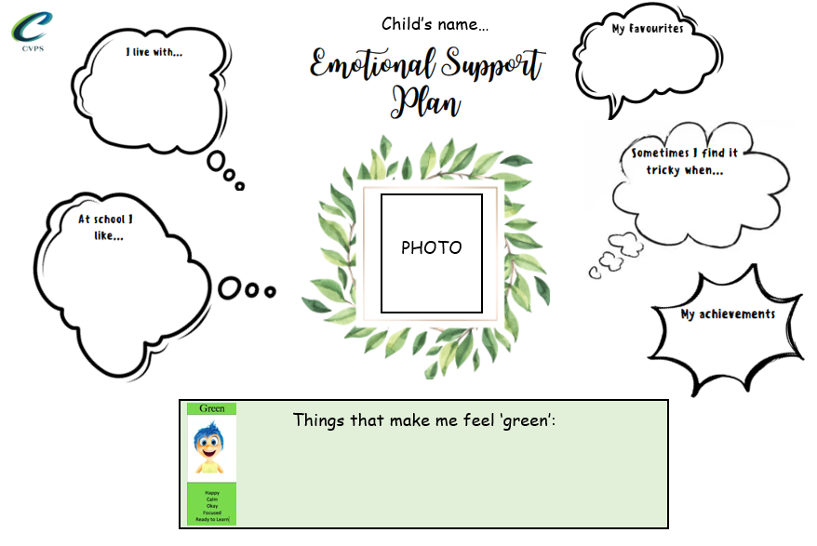

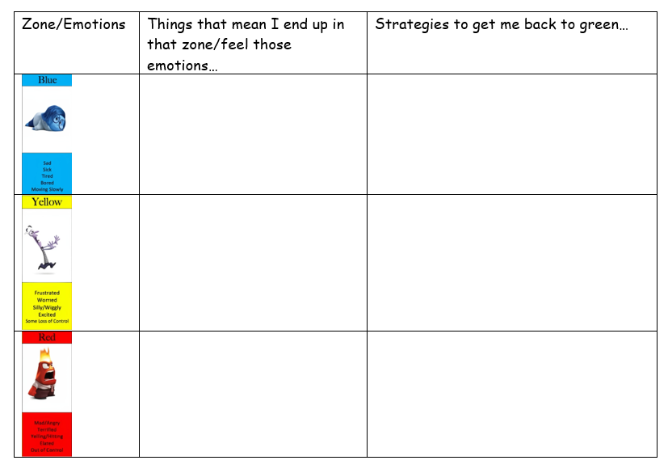

Appendix 2- Accountability Area Form to be completed by child as part of behaviour sanction

Accountability Area form

Name ___________________________________________________
Date ____________________________________________________

Reason for attending in my own words…..
______________________________________________________________________________________________________________________________________________________________________________________________________________________________________________________________________________________________________________________________________________________________________________________________________________________________________________________________________________________________________________________________________________________________________________________________
Which of the ‘Golden Expectations’ have I not followed? Please tick:
Being Kind
Being helpful and polite.
Being honest.
Being good listeners.
Looking after our environment.
Being safe and sensible around the school.
Enjoying our free time and allowing others to do the same.

What can I do next time to improve my behaviour?
________________________________________________________________________________________________________________________________________________________________________________________________________________________________________________________________________________________________________________________________________________________________________________________________________________________________________________________________________________________________________________________________________________________________________________________________________________________________________
Any further comments.
_________________________________________________________________________________________________________________________________________________________________________________________________________________________________________________________________________________________________________________________________________________________________________________________________

